


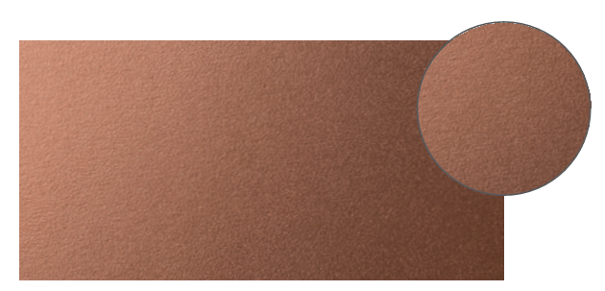

SPECIFICATION

HANDPLATE
DECOCHOC / DECOSMIC
PROTECTION AND COVERING PANELS – DECORATIVE CUTOUTS

- Description: 2 mm thick handplates (Nö, Glass, Lady, Man, Wooden, Dan, Eclipse, Plac’net or Delta masks as manufactured by SPM) from rigid and antibacterial PVC achieving Bs2d0 fire rating with solid colour and slightly textured surface.
- Environment: no heavy metals and no substance potentially subjected to any REACH restriction are used in its manufacture, nor PBT/BPA. The calcium-zinc thermal stabilisation process is used. The emission level of volatile substance in inside air has been tested according to ISO 16000-6 and is very low (A+) according to the French regulation (23 March 2011 nr 2011-321 Decree and 19 April 2011 Order). 100% of the product are recyclable.
- Colour: selected by architects from manufacturer’s standard range.
- Installation method: adhesive or glue as per manufacturer’s instructions.
